The temperature probe

The measuring of temperature was a big part of our project and to implement it we purchased a number of things:

* Pt-100 thermocuple
* M/F and M/M jumper wire
* Mpc-3008 ADC
* Breadboard
* 3.3 Kohm resistor

The pt-100 is an analog device and to convert the signal for the rpi we had to purchase the mpc-3008 an analog to digital converter. The mpc-3008 was chosen specifically because it was one of the cheaper and more commonly used adcs. The breadboard was purchased because of the simplicity in creating a breadboard circuit. 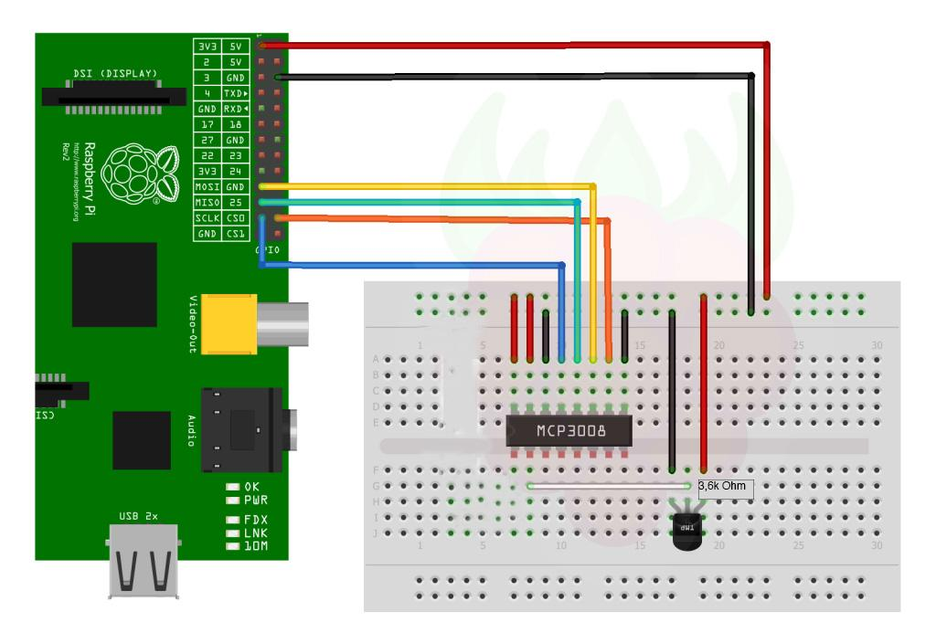

*Figure x: How our circuit appears on a larger breadboard*

Connecting the temperature probe also required work on the software side.

First of all the rpi uses GPIO-pins for connecting devices and to connect our adc and probe we had to change to protocol to SPI luckily rpi supports spi so the change was accomplished by simply changing a config file in rasbian.

To work with the signal on the rpi we used a python 2.7 library called spidev which was the most widespread library for this kind of thing.

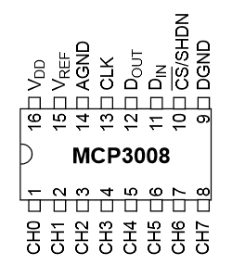

*Figure x:Breakdown of the ports on the adc*

Since the probe is a thermocouple the signal you receive from it is it’s resistance which means we that had to convert it into a celsius value using python.

As the team Fruitcakes needs additional parts, we decided to order the parts from China, since it is cheaper cost to buying it from China.

Items bought from china:

* mini speaker
* PT-100
* BerryClip 6 LED add on board
* LED
* clock model DS3231
* Raspberry Pi casing
* Button S1601

During the brainstorming meeting we make the decision about what kind of product we will develop with Raspberry Pi. After some researching on the what type of hardware needed and could be fit with pi. The first purchase was made on a chinese b2c website called “TaoBao” by delivery through DHL during one week. Through this method we solved financial issue and still maintain the quality of product.

**Conclusion**

The integration of our hardware into the project was started very late compared to the front end development which almost lead to it not being integrated. But during the last weeks of the project much focus was put on the hardware which lead to it being finished. When we ordered the first batch of items for the hardware no one really knew what we had to buy to connect the probe and it was ignored for a long time, luckily the components we needed were readily available from local electronic stores. The accuracy of the temperature probe could have been better if we bought a more expensive adc but accuracy was not really one of the goals so it was ignored. To conclude we had some issues when implementing the hardware but everything was resolved in an almost timely fashion.